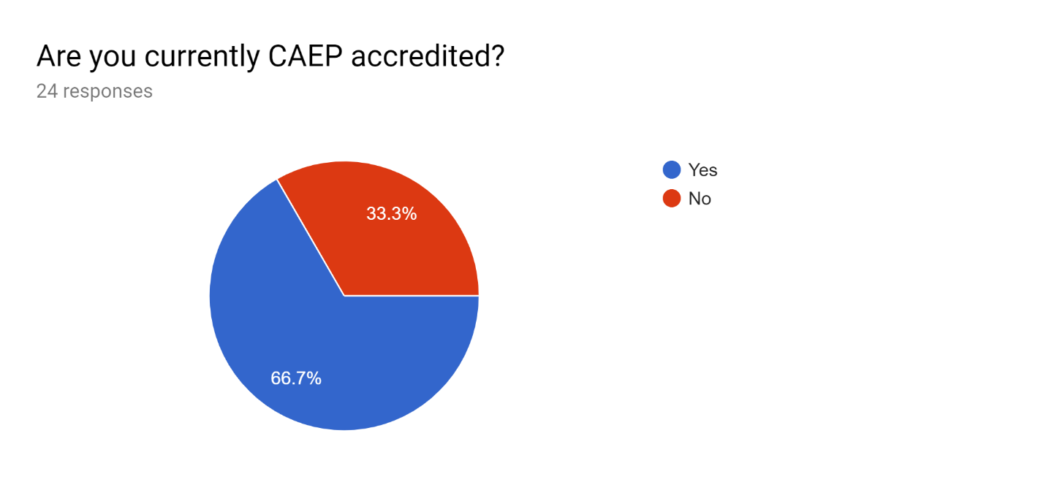
ECPC – OSEP Funded Personnel Preparation Grantees - IHE Needs Assessment
Sent out to 53 and received 24 responses
September 2019
If no, please list your accreditation body:
N/A
Accreditation Council for Occupational Therapy Education (ACOTE)
NCATE, but we considering changing to CAEP
program approvals by te state of Illinois (ISBE)
Georgia Professional Standards Commission; Commission on Colleges of the Southern Association of Colleges and Schools
WASC, California Teacher Credentialing
NCATE

