At-a- Glance Research Briefs
ECPC contracted with the Puckett Institute to investigate evidenced based pre-service and technical assistance practices. The Puckett Institute developed a meta-analysis describing the core elements of technical assistance that lead to sustainable programs and organization change (Dunst et al, 2018) and a meta synthesis describing high impact practices for pre-service teacher preparation (Dunst et al, 2019).
ECPC then created the At-a- Glance Research Briefs, which are designed to distill the findings of each study and support ECI personnel to utilize the information in their practice. The briefs are organized into two sets: 1) The Core Elements of Technical Assistance, which includes a total of six briefs, and 2) The Core Practices for Pre-Service Personnel Preparation, which includes a total of eight briefs.
The briefs were first created in May of 2019, with a plan for an iterative process of revisions and updates based on feedback from our early childhood workforce stakeholders (including National TA Center personnel, Part B/619 coordinators, Part C coordinators, faculty, family members and other stakeholders engaged in ECPC activities). Participants were asked to rate the briefs on a five-point feedback scale (ranging from 1 strongly disagree to 5 strongly agree) along the following seven variables: substance, communication, needs, pertinence, reach, ease and suitability. A “Not Applicable” (NA) option was provided. In addition, participants were invited to provide written comments on each of the seven variables.
Table 1 illustrates the data gathered during the months of July, August and September. These data informed the revisions.

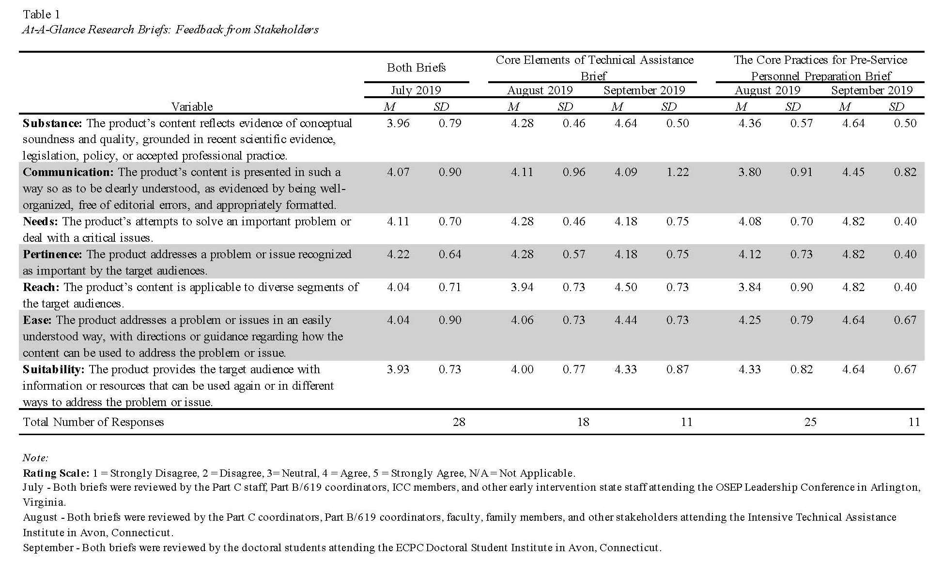
In July of 2019, during the OSEP Leadership Conference, data were gathered from 28 participants, including Part C coordinators, Part B/619 coordinators, ICC members and other early intervention staff members. Participants were asked to evaluate t both sets of briefs using the feedback scale. The areas of communication, needs, pertinence, reach and ease all had positive responses, with an average mean rating of 4.04 (SD= .71, .90) or greater. Two areas, substance and suitability, had mean ratings of 3.93 (SD = .73) and 3.96 (SD = .79), respectively, illustrating a neutral to positive response. Comments collected during the July review included: participants liked the overall organization of the information; there was a lot of information; and request for explicit connection to the intended audience.
Following the July review, ECPC asked that reviewers evaluate each set of briefs separately. Data were gathered at two ECPC events, also found in Table 1. The first was in August at the Intensive Technical Assistance Institute in Avon, CT. Participants reviewing the documents included Part C coordinators, Part B/619 coordinators, IHE faculty, family members and other early intervention staff members who work in a state receiving intensive TA from ECPC to develop a Comprehensive System of Personnel Development (CSPD). The second event, held in September, was the ECPC Doctoral Student Institute in Avon, CT. Participants reviewing the documents were doctoral students.
The following section presents a summary of each set of brief, with combined statements from the August and September groups.
Feedback from the two groups (N= 29) on the Core Elements of Technical Assistance Briefs were all positive, demonstrated by the mean for each of the six areas, across both groups ranged from 4.00 (SD = .77) to 4.64 (SD = .50). There was one exception in the August group, with the variable of Reach or addressing diverse audiences having a mean rating of 3.94 (SD = .73). Comments from the group were focused on the color schemes, formatting and need.
Feedback from the two groups (N=36) on the Core Practices for Pre-Service Personnel Preparation similarly demonstrated positive agreement with the six areas. For most of the areas, the mean score ranged from 4.08 (SD = .70) to 4.82 (SD = .40). Two elements were an average rating of high neutral, Communication, with a mean of 3.8 (SD = .91) and Reach with a mean of 3.84 (SD = .90). Comments from this set of briefs were consistent with those from the July reviewers. The August participants liked the briefs and their organization; however, they requested information regarding the audience, table/graph suggestions, and clarifying language to describe some of the practices in the briefs.
With the feedback provided from the three groups the following edits were made to each set of briefs:
- Technical language was edited to more pragmatic language. The overview of the study was edited to read more easily by practitioners. Definitions were added to clarify practices.
- The purpose was edited to improve the connection to reflect the audience of ECI practitioners.
- Edits made to grammar, formatting of tables, different graphics to display practices more clearly and succinctly.
The next set of reviews will be completed at the ECPC preconference at the 2019 October DEC Conference.

References
Dunst, C., Hamby, D., Howse, R., Wilkie, H., & Annas, K. (2019). Metasynthesis of preservice professional preparation and teacher education research studies, Education Sciences, 9(50), 1-36.
Dunst, C. J., Annas, K., Wilkie, H., & Hamby, D. W. (2018). Review of Studies and Evaluations of the Effects of Technical Assistance on Program, Organization, and Systems Change, International Journal of Evaluation and Research in Education (IJERE), 8(2), 330-343.

