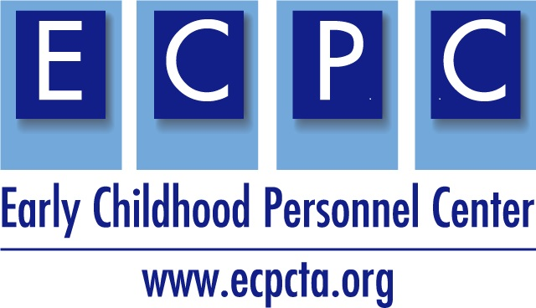

619 Videos Illustrating DEC Recommended Practice Categories Draft 10/1/19

ASSESSMENT
Video | Owner/Source | State posting | Cross-Disciplinary Category
Standardized Evaluation Pre-K (runtime 3:20) A child is evaluated using a standardized instrument in order to measure the early childhood outcomes adopted by the Office of Special Education Programs (OSEP). Illustrates testing picture vocabulary recognition, pointing to body parts, and answering “which one does not belong” questions.  https://vimeo.com/123438609 | Maryland State Department of Education/Division of Early Intervention and Special Education | MD | Evidence Based Intervention

ENVIRONMENT
Video | Owner/Source | State posting | Cross-Disciplinary Category
Connect Video 1.8: Routines in the Community–Going to the Store (runtime 1:06) Preschooler Luke is able to participate in a family trip to the grocery store using sign language and a speech generating device to communicate.  https://www.connectmodules.dec-sped.org/connect-modules/resources/videos/video-1-8/ | Early Childhood Personnel Center |  | Evidence-based Intervention

INSTRUCTION
Video | Owner/Source | State posting | Cross-Disciplinary Category
Meaningful Inclusion in Early Childhood (runtime 5:52) Parents reveal the benefits of inclusion for their child while educators describe and show examples of what they do and how they got there.  https://youtu.be/a2wJqDw9B68 | Wisconsin Department of Public Instruction | WI | Evidence Based Intervention
Connect Video 3.5: Conversation with Examples of Joining and Supporting (runtime 3:12) Collaboration between a Head Start teacher and an SLP to address the learning goals of Andi, a 4-year old  https://www.connectmodules.dec-sped.org/connect-modules/resources/videos/video-1-8/ | Early Childhood Personnel Center |  | Collaboration and Coordination
Connect Video 3.3: Conversation with Examples of Attending and Active Listening (runtime 2:37) Discussion between a Head Start teacher and an SLP about ways to address the learning goals of Andi, a 4-year old using attending and active listening.  https://www.connectmodules.dec-sped.org/connect-modules/resources/videos/video-3-3/ | Early Childhood Personnel Cent |  | Collaboration and Coordination
Connect Video 3.4: Conversation with Examples of Seeking and Verifying Information (runtime 2:38) Discussion between a Head Start teacher and an SLP about ways to obtain and verify information about a 4-year old child’s communication skills.  https://www.connectmodules.dec-sped.org/connect-modules/resources/videos/video-3-4/ | Early Childhood Personnel Center |  | Collaboration and Coordination

INTERACTION

Video | Owner/Source | State posting | Cross-Disciplinary Category
Early Childhood Social and Emotional Learning (runtime 4:16) Pre-K teachers describe and show examples of implementing the pyramid model for children of all abilities.  https://youtu.be/ohzEujRKtLg | Wisconsin Department of Public Instruction | WI | Evidence Based Intervention

TRANSITION

Video | Owner/Source | State posting | Cross-Disciplinary Category
Transition from Early Intervention to Preschool: Model IEP Meeting (runtime 14:06) Parents prepare and participate in their first IEP meeting as their child transitions out of early intervention and into early childhood special education.  https://www.youtube.com/watch?v=MWnbHPMg2EA | Utah Parent Center | UT | Coordination and Collaboration

