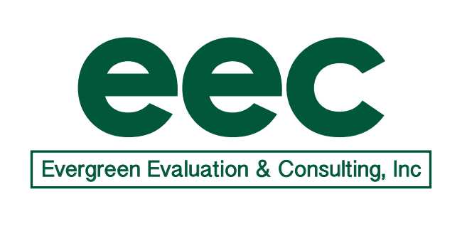

Date: 7/31/19
To: Mary Beth Bruder
CC: Kelly Ferreira, Betsy Howe

From: Pat Mueller, Evergreen Evaluation & Consulting, Inc.
Subject: Progress Report for ECPC 2.0

PROGRESS REPORT: July 2019

- Accomplishments to date (during July)
- Held Evaluation Team call on July 9 (see notes below).
- Prepped for and participated in 3+2 review.
- Updated Data Collection Schedule.
- Reviewed Smartsheet data on intensive states

- Planned Accomplishments (planned for August)
- Hold Evaluation Team call on August 6 at 11:00.

- Invoice (forwarded separately)

EEC-ECPC Evaluation Call
July 9, 2019

Participants: Mary Beth, Kelly, Betsy, Pat, Arlene, Vicki
Updates - including debrief regarding 3+2 review
- ECPC has received no comments from Tracy about the 3+2. Jeannette reported that the reviewers had no major issues, but she thinks OSEP is asking ECPC to do too much and is not communicating effectively.
  - ECPC may be instructed to change their scope, which will affect evaluation activities.
  - ECPC is supposed to receive the 3+2 report within a month.
- The collaboration between ECPC and ECTA is still tentative and planned activities may need to be revised based on the information ECPC receives from OSEP.
  - Mary Beth will update Pat on the outcome of a meeting about collaboration on 7/15 so Pat is prepared for her call on 7/18 about evaluating the collaboration.
Data collection overview
- Arlene developed a data collection overview in Excel to plan out what data ECPC needs to collect and when.
  - Items that contain an “X” mean that the activity would generate a report but not necessarily that the report is completed.
- Mary Beth informed EEC about upcoming activities:
  - Three higher education institutes: DEC pre-conference session, AUCD session, and TED session, all in the fall.
  - Doctoral Leadership Seminar on 9/10.
  - Meeting on 8/17 with three ITA states (HI, MS, MN) to review components of CSPD.
    - The ITA states have gone through the TA application and completed their MOUs and strategic planning.
      - Betsy will put all of these documents in SmartSheet today.
    - The 8/17 meeting may be a good opportunity to collect ITA data, or at least begin thinking about case studies.
- ECPC will schedule some state Leadership Institutes to take place in the fall before OSEP makes any changes to the center’s scope.
- Mary Beth also reported that ECPC needs to push more product development. They are bringing a few briefs to the OSEP Leadership conference for feedback.
  - The ECPC team will collect data about the briefs but will let EEC know if they want assistance with analysis or developing infographics.
Next steps for data collection instrument development
- Arlene will work on developing a document review protocol to allow for greater consistency.
Smartsheet access
- Kelly added Arlene in SmartSheet. All relevant state documents will be available in SmartSheet as soon as possible.
Next call: Tuesday, August 6 at 11:00 am EDT
EEC Conference Line: 802-255-4060

