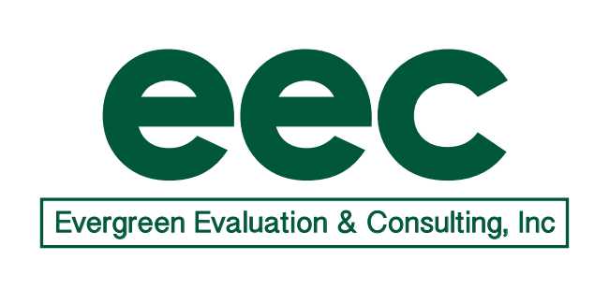

Date: 8/31/19
To: Mary Beth Bruder
CC: Kelly Ferreira, Betsey Howe

From: Pat Mueller, Evergreen Evaluation & Consulting, Inc.
Subject: Progress Report for ECPC 2.0

PROGRESS REPORT: August 2019

- Accomplishments to date (during August)
- Held Evaluation Team call on 8/6 (see notes below).
- Reviewed documents in Smartsheet.
- Prepped for and presented on Evaluation 101 for the Leadership Institute.

- Planned Accomplishments (planned for September)
- Hold Evaluation Team call on September 9 at 11:00.

- Invoice (forwarded separately)

EEC-ECPC 2.0 Evaluation Call
August 6, 2019

Present: Mary Beth, Pat, Arlene, Kelly, Betsey

- Update on 3+2
  - There has been no report as of yet
  - As of last week, ECTA had not heard either. Their 3+2 was in mid-May.
  - Tracie indicated that Christy would advocate for ECPC to continue work on all objectives and activities of the work plan, if the recommendation is to reduce the work scope.
- OSEP/Tracie has requested that they would like to ECPC to make a video to attract personnel into the field of ECI possibly using 100,000.00 of set aside money
- ECPC will continue moving forward with conducting Leadership Institutes as planned as they have not been asked to stop and OSEP wants to ensure that all of the money for 2019 is spent.
  - Upcoming Institutes include (Betsey will send out calendar as well)
    - Intensive/CSPD states coming to CT August 18th to the 21st
    - Part C & B coordinators for a Think Tank September 9th to the 11th
    - Doctoral Students September 11th-14th
    - Possible OSEP funded grantees September 23rd to 26th
    - Leadership states October 21st-23rd
    - HE meeting at TED
    - Leadership states November 11th-13th
    - Possible Leadership/Family 9th-11th
- ECPC will administer a survey at the Partners Meeting in September. Both the Cross Disciplinary Workgroup and Partners will gather in D.C. in September at a date yet TBD. Tom Hehir will be the keynote speaker. The meetings will be held at the Crystal Gate Marriott.
- Mary Beth said ECPC will be digging deeper into the work of the faculty in the IHE group to ascertain if they are completing their action plan objectives.
  - Rubrics are being created for faculty to use to align their courses/program of study to standards and DEC RP. Rubrics will ensure fidelity to content.
  - ECPC is also looking to support IHE faculty and Doc students to create action plans with more measurable and objective benchmarks
    - The current action plans will serve as our baseline measure
    - They will be on Smartsheet once we analyze them
- ECPC is also looking to do surveys of IHE to find out more about programs and content.
- Kelly is working on a report to summarize the data gathered at both the Part C coordinators meeting and Part B coordinators meeting in D.C. in July.
- ECPC did 3 presentations at the OSEP Leadership conference. They are posted on the OSEP website.
- EEC will review information on the following states for potential case studies. Arlene will start to organize the info and then gather data in the spring of 2020 at the next Intensive/CSPD Institute. They are using the Strategic Planning Guide and Intensive TA Manual.
  - MN is a reboot
  - AZ is a reboot
  - HI is underway
  - MS is just started

Next call is September 9, 2019 @ 11:00 (802 255-4060)

