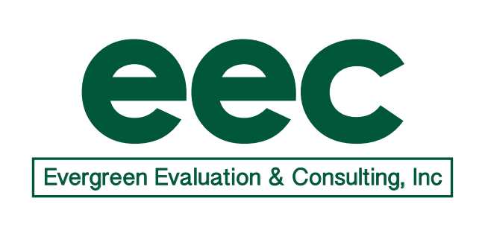

Date: 9/30/19
To: Mary Beth Bruder
CC: Kelly Ferreira, Betsey Howe

From: Pat Mueller, Evergreen Evaluation & Consulting, Inc.
Subject: Progress Report for ECPC 2.0

PROGRESS REPORT: September 2019

- Accomplishments to date (during September)
- Held Evaluation Team call on 9/9 (see notes below).
- Reviewed documents in Smartsheet.

- Planned Accomplishments (planned for October)
- Hold Evaluation Team call on October 9 at 11:00.
- Draft TA Quality Rating Rubric protocol for review by team.
- Brainstorm and determine method for analyzing Action Plans.
- Review 3+2 report, once received.

- Invoice (forwarded separately)

EEC-ECPC Evaluation Call
September 9, 2019

Participants: Kelly, Arlene, Vicki

Update on 3+2 report status
- To the best of Kelly’s knowledge, ECPC has not yet received their 3+2 report.

Update on TA plans (intensive TA to states, leadership institutes)
- ECPC is moving forward with work in their ITA states at this time. They hosted an institute with their 4 current ITA states in August and are not adding any additional ITA states for now.
- Arlene reported that she could not find any information in SmartSheet for the ITA states.
  - Kelly thinks that Betsy created a new version of the internal evaluation sheet and will check with Betsy to make sure Arlene receives access to the current sheet.
- For PM 3o, a data source specified in the evaluation plan is a TA Quality Rating Rubric.
  - Arlene will draft the rating rubric, and then share it with ECPC for review.

Potential data collection regarding IHE performance measures
- Arlene asked if ECPC is able to share action plans that the IHEs developed.
  - Kelly explained that the IHEs completed their action plans over the summer and the plans should be in SmartSheet. Kelly will confirm with Betsy that Arlene can also access the action plans.

Next call: Wednesday, October 9 @ 11:00 EST
EEC Conference Line: 802-255-4060

