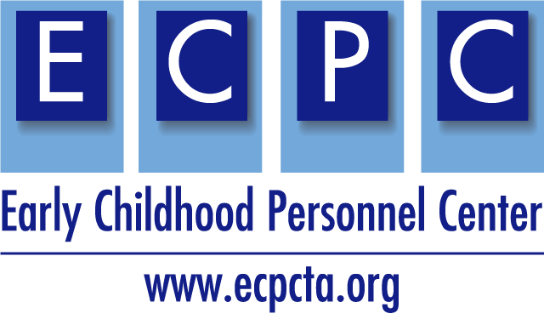

This example syllabus provides resources, activities, readings, and assignments, aligned with the personnel preparation standards and recommended practices. Consider state and university policies and add as appropriate.

ECPC Example Syllabus
Environment: Planning Inclusive Early Childhood Programs
Semester Year
Instructor:  Office:  Email:  Phone: | Primary Delivery Format:  Class Location: Online (Blackboard)  Office hours: By appointment, schedule via email
**Indicate preferred method of communication and response time to be expected.

Course Information
Course Description
Sample description: Design and evaluation of environments, curriculum development, activity planning, individualized instruction, and adaptions to meet the needs of infants and young children with unique needs within inclusive early care and education settings. Also focuses on supporting social and emotional development and play. 3 Credits.

Course Delivery Method
Teaching Methods
Describe how the course content will be delivered, and how students will be encouraged to reflect on course content and relate to their own experiences.

Mode of Instruction
Describe how the course will be taught (e.g., weekly readings and discussions, flipped classroom). Include time format also (e.g., asynchronous, synchronous, in-person, weekly).

Digital Services Required
Describe technology requirements and resources needed for course (e.g., Blackboard, Zoom, Google Suite).

Instructional Materials and Resources
Course Readings
Example: Students will be assigned readings from the required text. Additionally, students will read relevant research articles or supplemental materials, which will be posted to the Blackboard course site.

Required Text (Insert textbook title and access, and/or recommended text)
Example:
- Cook, R.E., Klein, M.D., & Chen, D. (2020). Adapting early childhood curricula for children with special needs (10th ed.). Upper Saddle River, NJ: Pearson.
- Catalino, T., & Meyer, L. E. (Eds.). (2016). Environment: Promoting meaningful access participation and inclusion (DEC Recommended Practices Monograph Series No. 2). Washington, DC: Division for Early Childhood.
Resources
- CEC Initial Preparation Standards
- CEC Initial Specialty Set: ECSE/EI
- NAEYC Initial and Advanced Preparation Standards
- Standards alignment with CEC, DEC, NAEYC
- DEC Recommended Practices crosswalk
- Connect Modules
- Early Childhood Recommended Practices Modules

Journals in EI/ECSE
Journals that publish early childhood and early intervention (there are many more, but these are excellent choices for you to consider). Consider explaining how to use these to support practice and to examine current research – clarify the difference between practitioner-based journals and research-based journals.
- Infants and Young Children  - Topics in Early Childhood Special Education  - Journal of Early Intervention  - Journal of Special Education Technology  - Young Exceptional Children  - Teaching Exceptional Children  - Rural Special Education Quarterly | - Intervention in School and Clinic  - Journal of Early Hearing Detection and Intervention  - International Journal of Early Childhood Special Education  - Young Children

Click here for Early Childhood Personnel Center resources.

Click here for NAEYC Program Standards for Early Childhood Program accreditation.

Course Goals and Objectives
Course Goals
Indicate what will be learned in the course. Goals should be stated as broad, generalizable statements.

Example: This course focuses on the design and evaluation of environments, curriculum development, and individualized planning and instruction for inclusive early care and education programs for children ages 3-5 with developmental delay and identified disabilities.

Instructional Objectives
These should be specific and measurable student behaviors. Think of these objectives as the tools that you will use in your course to ensure that the course goals are being reached.

Student Learning Outcomes
Using specific statements, describe the knowledge, skills, and dispositions that students are expected to learn through their successful completion of the curriculum.
Examples: As a result of active participation and successful completion of course requirements, students will:
- Reflect upon professional practice to promote professional growth.
- Identify and describe curricular approaches and models used in early childhood education and early childhood special education.
- Identify and discuss recommended practices and appropriate approaches for assessment of young children for the purposes of programmatic and curricular planning.
- Identify, describe characteristics of and formulate high-quality outcomes/goals and objectives for young children in collaboration with the family and other team members.
- Evaluate and design learning environments that facilitate maximum independence and active engagement in play, exploration, social interactions, and learning opportunities by young children with diverse abilities, backgrounds, experiences, and interests.
- Describe, plan, and implement methods for embedding individualized instruction and learning opportunities into children’s play and existing classroom activities and routines.
- Demonstrate understanding of various adaptions and assistive technologies to accommodate the unique learning styles and needs of young children with diverse abilities, including children with disabilities.
- Demonstrate practices that can be used to support peer interactions, social play, conflict resolution, and friendships amount preschoolers including children with disabilities.

Personnel Preparation Standards
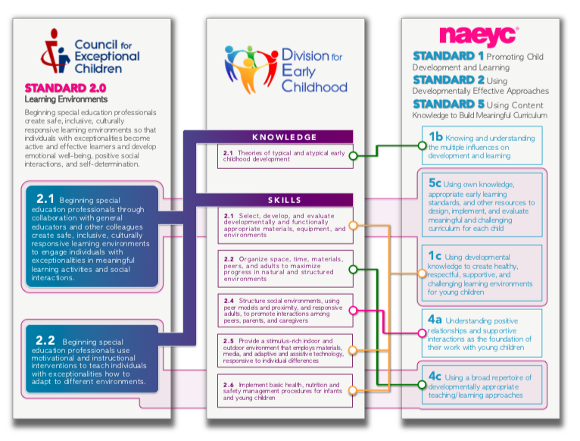
Consider additional preparation standards that support your course content. See links in Resources section.

DEC Recommended Practices
Consider additional Recommended Practices that may be applicable to your course content.

Use this link for examples of the recommended practices: Environment Examples
E1. Practitioners provide services and supports in natural and inclusive environments during daily routines and activities to promote the child’s access to and participation in learning experiences.
E2. Practitioners consider Universal Design for Learning principles to create accessible
environments.
E3. Practitioners work with the family and other adults to modify and adapt the physical, social, and temporal environments to promote each child’s access to and participation in learning experiences.
E4. Practitioners work with families and other adults to identify each child’s needs for assistive technology to promote access to and participation in learning experiences.
E5. Practitioners work with families and other adults to acquire or create appropriate
assistive technology to promote each child’s access to and participation in learning
experiences.
E6. Practitioners create environments that provide opportunities for movement and regular physical activity to maintain or improve fitness, wellness, and development across domains.

Use this link for examples of the recommended practices: Assessment Examples
Assessment
A3. Practitioners use assessment materials and strategies that are appropriate for the child’s age and level of development and accommodate the child’s sensory, physical, communication, cultural, linguistic, social, and emotional characteristics.
A7. Practitioners obtain information about the child’s skills in daily activities, routines, and
environments such as home, center, and community.

Use this link for examples of the recommended practices: Instruction Examples
Instruction
INS2. Practitioners, with the family, identify skills to target for instruction that help a child
become adaptive, competent, socially connected, and engaged and that promote
learning in natural and inclusive environments.
INS4. Practitioners plan for and provide the level of support, accommodations, and
adaptations needed for the child to access, participate, and learn within and across
activities and routines.

Grading and Course Expectations
Course Guidelines (Modify content as needed for your class.)
 | Before Class Sessions | During Class | Assignments
Be Respectful | - Come prepared to engage in discussions and activities. | - Use appropriate and professional language.  - Honor diverse opinions and perspectives.  - Use “person-first” language when addressing someone with a disability. Ex. “A person with autism” | - Obtain instructor permission prior to due dates if more time is needed.
Be Responsible | - Read and/or view expected context before class sessions.  - Contact instructor if you are unable to attend class. | - Attend class sessions and actively participate in discussions and activities.  - Maintain personal, student and school confidentiality.  - Ensure technology is turned off to eliminate distractions for yourself and others. | - Submit original work.  - Maintain academic integrity.  - Submit assignments on time.  - Submit electronically via Blackboard
Be Informed | - Follow syllabus, guided notes and class presentations regarding content to be read or viewed. | - Check your email regularly.  - Be alert to cancellations due to weather, instructor emergency, etc. | - Identify assignment due dates.  - Ask questions about assignments.  - Assignments can be revised with instructor permission.

Attendance and Participation
Example: This is a fast-paced and interactive on-line class. Students “attend” class by accessing learning materials and completing activities posted on the Blackboard site, and by participating actively in the online discussion board. Participation in the discussion boards is a graded
requirement of the class and missed deadlines without prior permission or without a valid excuse will result in a reduced grade for that week’s class.

Course Assignments and Standards/RPs Crosswalk
Standards & Recommended Practices | Student Learning Objective | Assignment | Points Possible
(Align assignment with Preparation Standards and DEC RPs.) | (Clearly articulate SLO.) | (Assignments are relevant and applicable.) | (Create rubrics for each assignment. List grading criteria.)
Environment  E1, E2, E6 | Evaluate and design learning environments | Group Project Developing Inclusive Environment
*In addition, consider the addition of CEC High Leverage Practices.

Sample Assignment for Environment
(Include clear instructions for each assignment and a rubric for measuring success).

Developmentally Appropriate Lesson Plans. Students will develop five lesson plans designed with a universal design for learning approach – think about what is needed from the beginning to support ALL children. Include early learning standards addressed. Lesson plans should be appropriate to the children’s age and developmental levels, respond to the interests of the children in the practicum setting, fit the definition of authentic activities, and occur within the context of typical daily routines. Students should consider a wide range of learning contexts and experiences such as free play activities (e.g., shoe store, washing babies, building roads and bridges); activities within learning centers (e.g., dramatic play, blocks, art, sensory); daily routines (e.g., brushing teeth, hand washing, and snack time); project work; field trips; circle time or large and small group activities.

Tentative Course Schedule
(Include a course schedule for transparency of expectations. Example topics, readings and assignments below.)

(Consider the field placement and/or practicum requirements and add as needed.)
Date | Topic and Learning Activity | Weekly Explorations Readings Links | Assignments Due
Week 1 | Topic: Introductions and Overview of Course  *Syllabus/Assignments scavenger hunt  *Setting the stage: Issues and context for early childhood program and environments  Topic: What is an inclusive environment?  *Knowledge and competencies for inclusive environments  *Current issues and challenges for the early childhood field | Catalino & Meyer (2015): Environment  Cook et al. Ch.1 | Reflection paper Syllabus quiz Discussion group Video introduction
Week 2 | Topic: Partnering with Families  *How to partner with families  *Family systems  *What types of supports do families need?  Topic: Parents as team members  *Working with diverse families  *How to engage families | Cook et al. Ch. 2 | Discussion Groups Content Quiz
Week 3 | Topic: Developing Individual Plans  *IFSP/IEP Process  *IEP Team  *Writing program goals  *Becoming a skilled observer | Cook et al. Ch. 3 | Observation videos
Week 4 | Topic: Designing Instructional Programs  *What is curriculum?  *What is UDL?  *Arranging the environment  *Embedding teaching and learning opportunities | Cook et al. Ch 4  Campbell & Milbourne (2014) | Groups assignments  Discussion Groups
Week 5 | Topic: Curriculum Approaches  *Reggio Emilia  *Montessori  *Project Approach  *Play-based | Beneke & Ostrosky (2015)  Hewett (2001) | Videos
Week 6 | Topic: Teaching Children with Disabilities  *Health impairments  *ASD  *Visual disabilities  *Difficulties in Learning | Cook et al. Ch. 5 | Discussion group
Week 7 | Topic: Managing early childhood programs & Addressing challenging behaviors  *Becoming emotionally secure  *Building a healthy environment  *Facilitating social skills  *Behavior modeling | Cook et al. Ch. 6  Jolivette & Steed (2010)  Tal (2010) | Content quiz
Week 8 | Cont.: Managing early childhood programs & Addressing challenging behaviors  *Encouraging developmental play behavior  *Temperament  *PBS  *Social Stories | Explore websites:  http://csefel.vanderbilt.edu/  https://www.pbis.org/  https://www.autismspeaks.org/what-autism | Resource list  Discussion Groups
Week 9 | Topic: Motor and Self Care Skills  *Developmental motor skills  *Assessment of motor skills  *Development of adaptive behavior skills  *Adapting environment | Cook et al. Ch 7 | Discussion Groups
Week 10 | Topic: Communication Skills  *Content, use, form  *Prelinguistic communication  *Communication development | Cook et al. Ch. 8
Week 11 | Topic: Cognitive skills  *What is cognition?  *Cognitive process  *Development of cognitive skills  *Cognitive skills through the development of play  *Supporting cognitive development  *Intellectual disabilities | Cook et al. Ch. 9 (p. 282- 297)
Week 12 | Topic: Literacy skills  *Information processing  *Emergent math  *Development of literacy  *Cultural differences in language and literacy  *Family advocacy | Cook et al. Ch. 9 (p. 297-324)
Week 13 | Topic: Promoting STEAM Families as partners | Donegan-Ritter (2015)  Horn et al. (2016)
Week 14 | Topic: Teaming  *Collaboration and problem solving  *Co-teaching approach  *Effective teaming with interdisciplinary specialists | Cook et al. Ch. 10
Week 15 | Topic: Program Evaluation  *Purposes of evaluation  *Monitoring and controlling for quality  *Program evaluation

