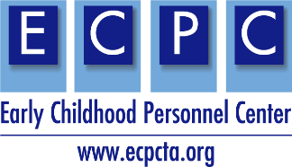

This example syllabus provides ideas, resources, activities, readings, and assignments, aligned with the personnel preparation standards and recommended practices. Consider state and university policies and add as appropriate. This is an example only and is not a complete syllabus.

ECPC Example Syllabus
Topic: Assessment
Semester Year
Instructor:  Office:  Email:  Phone: | Primary Delivery Format:  Class Location: Online (Blackboard)  Office hours: By appointment, schedule via email
**Indicate preferred method of communication and response time to be expected.

Course Information
Course Description
Insert your course description as found in the course catalog.
Example. This course examines issues in measurement and test development, child find and screening, eligibility and programmatic assessment, nontraditional/authentic assessment, individualized intervention planning, collaboration with families in the IFSP process, methods of team assessment, and principles and strategies of intervention from an inclusive, culturally competent, family-centered perspective. An important focus is assessment and intervention strategies for infants and young children with low incidence disabilities (medically fragile/complex conditions, multiple or severe disabilities, autism, hearing loss, visual impairments). The course includes a practicum in which students practice carrying out an assessment of an infant or toddler using both standardized, norm-referenced, and authentic, non-traditional approaches. Additionally, students will practice summarizing assessment results in a concise but comprehensive, family-friendly report. 3 Credits.

Course Delivery Method
Teaching Methods
Describe how the course content will be delivered, and how students will be encouraged to reflect on course content and relate to their own experiences.

Mode of Instruction
Describe how the course will be taught (e.g., weekly readings and discussions, flipped classroom). Include time format also (e.g., asynchronous, synchronous, in-person, weekly).

Digital Services Required
Describe technology requirements and resources needed for course (e.g., Blackboard, Zoom, Google Suite).

Instructional Materials and Resources
Course Readings
Example: Students will be assigned readings from the required text. Additionally, students will read relevant research articles or supplemental materials, which will be posted to the Blackboard course site.

Required Text (Insert textbook title and access, and/or recommended text)

Resources
- CEC Initial Preparation Standards
- CEC Initial Preparation Standards Specialty Set: EI/ECSE
- NAEYC Initial Preparation Standards
- Advanced Standards alignment with CEC, DEC, NAEYC
- Connect Modules
- Early Childhood Recommended Practices Modules

Journals in EI/ECSE
Journals that publish early childhood and early intervention (there are many more, but these are excellent choices for you to consider). Consider explaining how to use these to support practice and to examine current research – clarify the difference between practitioner-based journals and research-based journals.
- Infants and Young Children  - Topics in Early Childhood Special Education  - Journal of Early Intervention  - Journal of Special Education Technology  - Young Exceptional Children  - Teaching Exceptional Children  - Rural Special Education Quarterly | - Intervention in School and Clinic  - Journal of Early Hearing Detection and Intervention  - International Journal of Early Childhood Special Education  - Young Children

Click here for Early Childhood Personnel Center resources.

Click here for NAEYC Program Standards for Early Childhood Program accreditation.

Course Goals and Objectives
Course Goals
Indicate what will be learned in the course. Goals should be stated as broad, generalizable statements.

Example: This course will introduce students to methods of child find, screening, evaluation, and assessment. Measurement concepts related to standardized assessments will be addressed. Assessment of all areas of a child’s development will be discussed. Active involvement of families in the assessment process is stressed, including involving families in the administration, integrating family priorities and concerns into the assessment process, obtaining assessment information and sharing assessment findings with families, and collaborating with the family in the development of an IEP/IFSP based on the assessment findings. The influence of culture and a child’s disability on the assessment process and methods for adapting assessment methods to accommodate a child’s disability will be addressed. Lastly, alternative approaches to assessing infants and young children will be discussed. Students will have the opportunity to learn how to work as a team in planning and administering assessments and writing integrated assessment reports with recommendations. The course will include opportunities for students to implement both authentic, non-traditional assessments and standardized norm-referenced assessments. A reflective blog will be used to assist students to examine their experiences and to integrate the course content with their work with families.

Instructional Objectives
These should be specific and measurable student behaviors. Think of these objectives as the tools that you will use in your course to ensure that the course goals are being reached.

Student Learning Outcomes
Using specific statements, describe the knowledge, skills, and dispositions that students are expected to learn through their successful completion of the curriculum
Examples: As a result of active participation and successful completion of course requirements, students will:
- Differentiate five purposes of assessment in early intervention (screening, determining eligibility, program planning, monitoring progress, evaluating the program) and discuss recommended practices for each purpose.
- Explain state and federal mandates related to assessment in early intervention and early childhood special education.
- Describe methods and procedures to effectively assess the development of infants and young children across all developmental domains, including norm-referenced tools, curriculum-based tools, and methods of observation and informal data collection.
- Explain measurement concepts used in the development of standardized tests and in analyzing and interpreting children’s performance on assessment instruments.
- Discuss issues related to child find and screening programs and considerations for selecting screening instruments.
- Produce assessment reports that clearly discuss the developmental domains addressed, strengths and needs of the child, functional concerns, and make appropriate recommendations based on the findings.

Personnel Preparation Standards

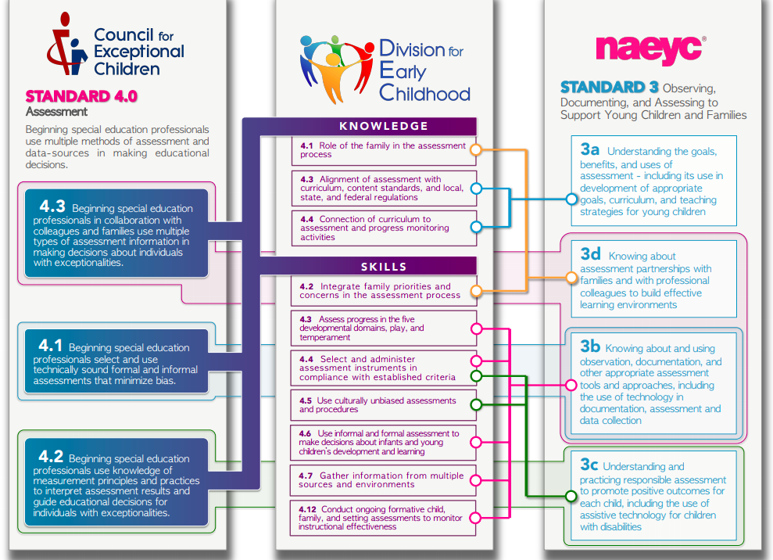
Consider additional preparation standards that support your course content. See links in Resources section.

DEC Recommended Practices addressed in this course
Consider additional Recommended Practices that may be applicable to your course content.
Assessment
Use this link for examples of the recommended practices: Assessment Examples
A1. Practitioners work with the family to identify family preferences for assessment processes.
A2. Practitioners work as a team with the family and other professionals to gather assessment information.
A3. Practitioners use assessment materials and strategies that are appropriate for the child’s age and level of development and accommodate the child’s sensory, physical, communication, cultural, linguistic, social, and emotional characteristics.
A4. Practitioners conduct assessments that include all areas of development and behavior to learn about the child’s strengths, needs, preferences, and interests.
A5. Practitioners conduct assessments in the child’s dominant language and in additional languages if the child is learning more than one language.
A6. Practitioners use a variety of methods, including observation and interviews, to gather assessment information from multiple sources, including the child’s family and other significant individuals in the child’s life.
A7. Practitioners obtain information about the child’s skills in daily activities, routines, and environments such as home, center, and community.
A8. Practitioners use clinical reasoning in addition to assessment results to identify the child’s current levels of functioning and to determine the child’s eligibility and plan for instruction.
A9. Practitioners implement systematic ongoing assessment to identify learning targets, plan activities, and monitor the child’s progress to revise instruction as needed.
A10. Practitioners use assessment tools with sufficient sensitivity to detect child progress, especially for the child with significant support needs.
A11. Practitioners report assessment results so that they are understandable and useful to families.

Use this link for examples of the recommended practices: Family Examples
Family
F3. Practitioners are responsive to the family’s concerns, priorities, and changing life circumstances.
F4. Practitioners and the family work together to create outcomes or goals, develop individualized plans, and implement practices that address the family’s priorities and concerns and the child’s strengths and needs.

Grading and Course Expectations
Course Guidelines (Modify content as needed for your class.)
 | Before Class Sessions | During Class | Assignments
Be Respectful | Come prepared to engage in discussions and activities. | Use appropriate and professional language.  Honor diverse opinions and perspectives.  Use “person-first” language when addressing someone with a disability. Ex. “A person with autism” | Obtain instructor permission prior to due dates if more time is needed.
Be Responsible | Read and/or view expected context before class sessions.  Contact instructor if you are unable to attend class. | Attend class sessions and actively participate in discussions and activities.  Maintain personal, student and school confidentiality.  Ensure technology is turned off to eliminate distractions for yourself and others. | Submit original work.  Maintain academic integrity.  Submit assignments on time.  Submit electronically via Blackboard
Be Informed | Follow syllabus, guided notes and class presentations regarding content to be read or viewed. | Sign up Blackboard notifications.  Check your email regularly.  Be alert to cancellations due to weather, instructor emergency, etc. | Identify assignment due dates on Blackboard’s class calendar, guided notes, class presentations and syllabus.  Ask questions about assignments in class, through email or during office hours.  Assignments can be revised with instructor permission.

Attendance and Participation
Example: This is a fast-paced and interactive on-line class. Students “attend” class by accessing learning materials and completing activities posted on the Blackboard site, and by participating actively in the online discussion board. Participation in the discussion boards is a graded requirement of the class and missed deadlines without prior permission or without a valid excuse will result in a reduced grade for that week’s class. Missing deadlines on more than one occasion without prior permission or a valid excuse will result in a discussion with the instructor about the student’s ability to continue with the class.

Course Assignments and Standards/RPs Crosswalk
*Create a chart similar to this to highlight personnel standards and RPs aligned with course assignments. In addition, consider the addition of CEC High Leverage Practices (HLPs) if used to support your program.
Aligned with  Assessment  (point values) | Personalize this form. For example, insert state standards, HLPs or SLOs. | CEC Initial Standards | CEC/DEC Initial Specialty Set: ECSE/EI | DEC RPs | NAEYC Advanced Standards
Assessment Review  (25 points) |  | Standard 4 | K4.2 |  | Standard 3
Assessment Project and Report  (125 points) |  | Standard 4 | K4.1  S4.1, S4.2, S4.6, S4.10 | A4, A6 | Standard 3

Sample Assignments for Assessment
Assessment Tool Review: Students will conduct a review of an assessment tool – which may be a screening tool, a norm-referenced assessment, or a criterion referenced assessment. The review should contain information about the intended purpose of the tool, target age range, domains assessed, reliability and validity information, a description of administration and scoring procedures, and a brief summary of the strengths and limitations of the instrument.

Assessment Project and Report: Students will conduct a developmental assessment of an infant or young child (birth to 3) and write up the results in an integrated report complete with appropriate recommendations. Students are required to use multiple assessment methods, including one norm-referenced assessment tool and at least two authentic assessment methods (e.g. observation in the natural environment, parent/caregiver interview, informal observation tool). Formal assessments must be conducted in at least 2 developmental domains (social-emotional and cognitive development at a minimum) but the report should take into account development in all domains. Please see assessment report rubric for additional guidelines.

Tentative Course Schedule
(Include a course schedule for transparency of expectations. Example topics, readings and assignments below.)

This course is an example of a FLIPPED classroom. You will gain first exposure learning prior to class and focus on the processing part of learning (synthesizing, analyzing, problem-solving). All content and readings are provided to you in the first seven weeks of the course so that you can then apply the information learned to the required assignments during the final weeks of the course. See due dates on course calendar.

(Consider the field placement and/or practicum requirements and add as needed.)
Date | Topic and Learning Activity | Weekly Explorations Readings Links  See additional readings on e-platform | Assignments Due
Week 1 | - Course overview  - Overview of assessment  - Legal basis of assessment in EI  - Best practices in assessment | Assessment: ch.1, ch.2 | Reflection paper Syllabus quiz Discussion group  Video introduction
Week 2 | - Interpreting test scores  - Eligibility determination  - Screening tools | Assessment: ch.3, ch.4  Center for Parent Information & Resources  See additional readings on e-platform  *consider having parents lead sessions and small group discussions | Discussion Groups Content Quiz
Week 3 | - Authentic assessment  - Observation techniques  - Rubrics, rating scales | Assessment: ch.5, ch.6  Panel presentations  Parent interviews  *consider having parents lead sessions and small group discussions | Battelle observation videos
Week 4 | - Informal data systems  - Criterion referenced tools  - Routines Based Interview | Parent interviews  *consider having parents lead sessions and small group discussions  See additional readings on e-platform | Discussion Groups
Week 5 | - Cultural & linguistic diversity  - Sensory impairments  - Severe & multiple disabilities | See additional readings on e-platform | Videos
Week 6 | - Autism  - Mental Health  - Challenging behavior | See additional readings on e-platform | Discussion Groups
Week 7 | - Writing assessment reports  - Selecting & writing goals and outcomes  - Data-based decision making  - Monitoring progress |  | Content quiz
Week 8 | Practicum and assignments
Week 9 | Practicum and assignments
Week 10 | Practicum and assignments | Small group conversations via Zoom: Routines-based early intervention
Week 11 | Practicum and assignments | Small group conversations via Zoom: Routines-based interview
Week 12 | Practicum and assignments | Small group conversations via Zoom: Types of assessments
Week 13 | Practicum and assignments | Small group conversations via Zoom: Families as partners
Week 14 | Practicum and assignments | Small group conversations via Zoom: Writing assessment reports
Week 15 | Final exam

