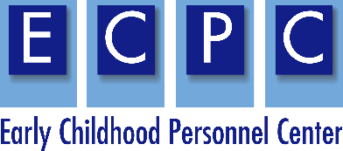

ECPC Family Cohort
December 1-4, 2019

Crafting your story

Your story should touch on a personal experience with early childhood services for y our child and/or other families. It could address the positive impact of well-trained personnel or the difficulties in working with personnel who are not comfortable engaging with family members.

Use the attached table to guide you in crafting your story.

Things to Consider | Your Story
What is the purpose or goal of your story?
What does your story illustrate?

Who is your audience?

What outcome would you like from the audience?

Is there a specific action, discussion or other outcome?

What powerful examples are you willing to share to illustrate this issue?
    - An event, challenge, hurdle, setback

    - Personal or professional growth; “transformative consequences”, triumph, success

How will you organize your points with your examples?

What visual aide, creative wording, reading, or “audience hooks” will you use?
(Ask the audience questions, share pictures, or weave visual images and emotion into your story.)
What solutions or suggestions will you give your audience?
How will you close?

I’m sharing this with you in the hopes that …

Have the courage to follow your heart and intuition…

What will you do if you get nervous or emotional and don’t know what to say next?

