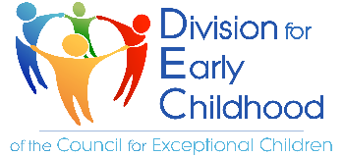
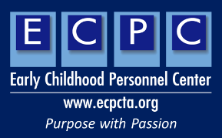
This Photo by Unknown Author is licensed under CC BY-NC-ND

Filling your toolbox: Identify EI/ECSE and related resources in your state
What is the lead agency for EI in your state?
Who is the Part C Coordinator?
Who is the Part B/619 Coordinator?
Who provides professional development for early intervention in your state?
Who is the Chair of your State ICC?
Who are the parents on the State ICC?
Who is the Personnel Preparation Representative on the State ICC (Interagency Coordinating Council)?
Who is the chair of the State Advisory Panel (SAP) or Special Education Advisory Council (SEAC)?
Where can you find information about early intervention in your state? Number of children served, eligibility criteria.
What higher education programs provide EI/ECSE personnel preparation in your state?
Does your state offer an EI Certification or Licensure?
Where is the UCEDD located? (University Center of Excellence in Developmental Disabilities)
Where is the LEND Program Located? (Leadership Education in Neurodevelopmental and Related Disabilities)
What is the name of the Parent Center in your state? (Parent Training & Information Center – PTI)
Where is Parent to Parent located in your state?
Where is Family Voices located in your state? F2F Health Information Center
Are there other family leaders or family organizations that may assist you with your action plan? Please list

