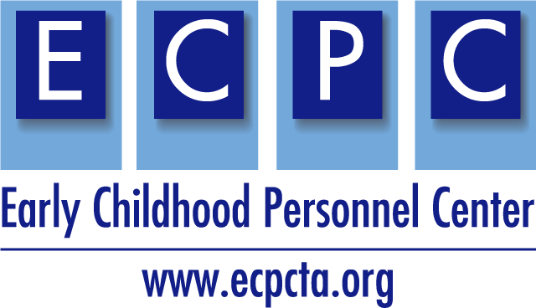
ECPC Checklist for Application Review

The ECPC Checklist for Application Review was developed for the U.S. Department of Education Office of Special Education and Rehabilitative Services, Office of Special Education Programs application for new grants under the Individuals with Disabilities Education Act (IDEA). The guidance contains information and resources for you to use when submitting a new application for funding under the Personnel Development to Improve Services and Results for Children with Disabilities: Preparation of Special Education, Early Intervention, and Related Services Leadership Personnel (CFDA 84.325D) program. This guidance does not replace the OSERS-OSEP application packet, found in its entirety on grants.gov.
Once you have written your project narrative, use this checklist and consider the elements that the Secretary will review and score within your completed application.

Area of Application Review: Significance
10 Points
- The extent to which the proposed project will prepare personnel for fields in which shortages have been demonstrated;  - The importance or magnitude of the results or outcomes likely to be attained by the proposed project; and  - The extent to which there is a conceptual framework underlying proposed research or demonstration activities and the quality of that framework. | How does your proposal address this?

What do you need to add, delete, or modify to strengthen this section?

Area of Application Review: Quality of project services
45 Points
The quality and sufficiency of strategies for ensuring equal access and treatment for eligible project participants who are members of groups that have traditionally been underrepresented based on race, color, national origin, gender, age, or disability.  In addition:  - The extent to which the training or professional development services to be provided by the proposed project are of sufficient quality, intensity, and duration to lead to improvements in practice among the recipients of those services;  - The extent to which the proposed activities constitute a coherent, sustained program of training in the field; and  - The extent to which the services to be provided by the proposed project reflect up-to-date knowledge from research and effective practice. | How does your proposal address this?

What do you need to add, delete, or modify to strengthen this section?

Area of Application Review: (c) Quality of project evaluation
25 points
- The extent to which the methods of evaluation are thorough, feasible, and appropriate to the goals, objectives, and outcomes of the proposed project;  - The extent to which the goals, objectives, and outcomes to be achieved by the proposed project are clearly specified and measurable;  - The extent to which the methods of evaluation include the use of objective performance measures that are clearly related to the intended outcomes of the project and will produce quantitative and qualitative data to the extent possible; and  - The extent to which the methods of evaluation will provide timely guidance for quality assurance. | How does your proposal address this?

What do you need to add, delete, or modify to strengthen this section?

Area of Application Review: (d) Quality of project personnel, quality of the management plan, and adequacy of resources 20 points
- The qualifications, including relevant training and experience, of key project personnel;  - The adequacy of the management plan to achieve the objectives of the proposed project on time and within budget, including clearly defined responsibilities, timelines, and milestones for accomplishing project tasks;  - The extent to which the time commitments of the project director and principal investigator and other key project personnel are appropriate and adequate to meet the objectives of the proposed project;  - The adequacy of support, including facilities, equipment, supplies, and other resources, from the applicant organization or the lead applicant organization; and  - The extent to which the budget is adequate to support the proposed project. | How does your proposal address this?

What do you need to add, delete, or modify to strengthen this section?

The contents of this checklist were developed under a cooperative agreement #H325B17008 from the Office of Special Education Programs, US Department of Education. However, those contents do not necessarily represent the policy of the US Department of Education, Project Officers, Tracie Dickson, PhD.

