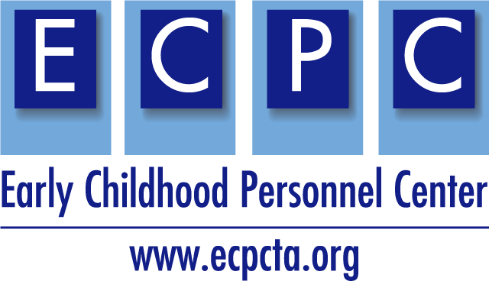
ECPC Leadership Personnel Preparation Grant Planning Guide
HOW TO USE THIS GUIDE:
The ECPC Personnel Preparation Grant Planning Guide was developed to provide considerations and writing guidance for the U.S. Department of Education Office of Special Education and Rehabilitative Services, Office of Special Education Programs application for new grants under the Individuals with Disabilities Education Act (IDEA). The guidance contains information and resources for you to use when submitting a new application for funding under the Personnel Development to Improve Services and Results for Children with Disabilities: Preparation of Special Education, Early Intervention, and Related Services Leadership Personnel (CFDA 84.325D) program. This guidance does not replace the OSERS-OSEP application packet, found in its entirety on grants.gov.
Applications Due: April 1, 2022
Personnel Development to Improve Services and Results for Children with Disabilities: Preparation of Special Education, Early Intervention, and Related Services Leadership Personnel (CFDA 84.325D) Program
PURPOSE OF THE PROGRAM

There is one absolute priority and one competitive priority for this grant opportunity:
- Absolute Priority 1: Preparation of special education, early intervention, and related services leadership personnel

*The purpose of this priority is to support existing doctoral degree programs that prepare special education, early intervention, and related services personnel at the doctoral degree level who are well qualified for, and can act effectively in, leadership positions as researchers and special education/early intervention/related services personnel preparers in IHEs or as leaders in State educational agencies (SEAs), lead agencies (LAs), local educational agencies (LEAs), or early intervention services programs (EIS programs).

NOTE: Partnerships comprised of two or three IHEs with existing doctoral programs that prepare scholars are included in this priority and eligible to apply for funding.

Competitive Preference Priority 1: Applications from New Potential Grantees
(To earn 0 points or an additional 3 points)

Eligibility Requirements

GUIDANCE: Writing the Application Narrative
The application narrative is where you, the applicant, address the selection criteria that reviewers use to evaluate your application.
- Significance of the Project (10 points)
- Quality of Project Services (45 points)
- Quality of Project Evaluation (25 points)
- Quality of Management Plan, and Adequacy of Resources (20 points)
In addition, for formatting purposes, the following is recommended:
- Limit the application narrative to no more than 50 pages and
- Use the following standards:
  - A “page” is 8.5″ x 11″, on one side only, with 1″ margins at the top, bottom, and both sides,
  - Double-space (no more than three lines per vertical inch) all text in the application narrative, including titles, headings, footnotes, quotations, reference citations, and captions, as well as all text in charts, tables, figures, graphs, and screen shots,
  - Use a font that is 12 point or larger, and
  - Use one of the following fonts: Times New Roman, Courier, Courier New, or Arial.
The recommended page limit does not apply to the following:
- cover sheet,
- budget section, including the narrative budget justification,
- assurances and certifications,
- abstract (follow the guidance provided in the application package for completing the abstract),
- table of contents,
- list of priority requirements,
- resumes,
- reference list,
- letters of support, and
- appendices
However, the recommended page limit does apply to the application narrative, including all text in charts, tables, figures, graphs, and screen shots.

Absolute Priority 1: Preparation of special education, early intervention, and related services leadership personnel

PURPOSE OF THE PRIORITY
To support existing doctoral degree programs that prepare special education, early intervention, and related services personnel at the doctoral degree level who are well-qualified for, and can act effectively in, leadership positions as researchers and special education/early intervention/related services personnel preparers in institutions of higher education (IHEs), or as leaders in State educational agencies (SEAs), lead agencies (LAs), local educational agencies (LEAs), early intervention services programs (EIS programs), or schools. Programs must culminate in a doctoral degree (PhD or EdD).
- Applicants must plan to recruit and enroll the proposed number of scholars in the application within the first 12 months of the project period or demonstrate that scholars enrolled after the first 12 months can complete the program by the end of the proposed project period.
- Preparation programs that lead to clinical doctoral degrees in related services are not included in this priority.
Note: Project periods under this priority may be up to 60 months. Projects should be designed to ensure that all proposed scholars successfully complete the program within 60 months of the start of the project. The Secretary may reduce continuation awards for any project in which scholars are not on track to complete the program by the end of that period.
PLANNING

Planning | Guidance/Resources
Use a logic model in the planning phase. A logic model provides a snapshot of your project and a structure for planning. It allows for a team approach to organizing inputs, outputs, and short-term and long-term outcomes of the proposal.  Once the logic model is complete, the narrative is easier to write. You may find it helpful to identify desired outcomes first and then work backwards through the logic model. | Presentations about the use of logic models:  IDEAS that Work Logic Models

Grant Narrative: (a) Significance (10 points)

(1) The project addresses the need for leadership personnel to promote high expectations and provide, or prepare others to provide, effective interventions and services that improve outcomes for children with disabilities, including high-need children with disabilities. To address this requirement, the applicant must present:  (i) Appropriate and applicable data (e.g., national, State) demonstrating the need for the leadership personnel the applicant proposes to prepare; and  (ii) Data demonstrating the success of the doctoral program to date in producing leadership personnel in special education, early intervention, or related services, such as: the professional accomplishments of program graduates (e.g., public service, awards, or publications) that demonstrate their leadership in special education, early intervention, or related services; the average amount of time it takes for program graduates to complete the program; the number and percentage of scholars who enroll and who graduate, including the number of scholars from underrepresented backgrounds; and the percentage of program graduates finding employment related to their preparation, including those serving students with disabilities in underserved communities (e.g., employed in districts with high rates of poverty); and | Guidance/Resources
What evidence is available within your state to help demonstrate a specific need for leadership personnel preparation for early intervention and early childhood special education (at all levels—teachers, district coordinators, district special education directors, all the way up to state personnel)?
- Explore local, state-specific data for information about the EIECSE workforce, personnel shortages, and PD needs. Explore potential partners, including state agencies who support EIECSE services.
- Also consider data that may have been collected by a parent training and information center for parents of children and students with disabilities within your state. These centers are potential partners in the process and can serve to include parent input and support any outcomes.
- Provide details about the students of the participating leadership personnel preparation programs. Include data on past graduates and employment, including challenges facing the statewide workforce.
- Consider the licensure, certifications and endorsements of your state and the benefits of the proposed project.

**Data on the success of a doctoral program should be no older than five years prior to the start of the project proposed in the application. When reporting percentages, the denominator (i.e., total number of scholars or program graduates) must be provided.
(2) Scholar competencies to be acquired in the program relate to the knowledge and skills needed by the leadership personnel.  To address this requirement, the applicant must:  (i) Identify the competencies needed by leadership personnel to provide, or prepare others to provide, effective interventions and services, including through distance education, that improve outcomes for children with disabilities, including high-need children with disabilities; and  (ii) Provide the conceptual framework of the leadership preparation program, including any empirical support, that will promote the acquisition of the identified competencies needed by leadership personnel. | Connect current educational and EI/ECSE state-level initiatives if possible. Be specific about how the personnel preparation of leaders will support and enhance the overall strategic plan for EIECSE education in your state and how it will strengthen all education initiatives.  Making this connection emphasizes the sustainability of this proposal and ensures a better return on investment (ROI).  What specific knowledge, skills and competencies do leaders need?  Logic model can serve as your conceptual framework. See notes above on resources and links for a logic model.  Resources for applicants:  Council for Exceptional Children Personnel Preparation Standards  Division for Early Childhood Personnel Preparation Standards  Division for Early Childhood Recommended Practices  NAEYC Professional Preparation Standards  Early Childhood Personnel Center –  ECPC Cross-disciplinary Personnel Competencies  What current partnerships do you have with child-serving agencies across the state?  - This would include any parent training and information center (PTI), universities, teacher organizations, professional organizations, and local education agencies.  - Parent Training and Information Centers and Community Parent Resource Centers funded by OSEP

Grant Narrative: (b) Quality of Project Services (45 points)

(1) Will recruit and retain scholars participating in the project and ensure equal access and treatment for eligible project participants who are members of groups that have traditionally been underrepresented based on race, color, national origin, gender, age, or disability. To meet this requirement, the applicant must describe—  (i) Selection criteria the applicant will use to identify high-quality applicants for admission in the program,  (ii) Recruitment strategies the applicant will use to attract high-quality applicants, including specific recruitment strategies targeting high-quality applicants from traditionally underrepresented groups, including underrepresented individuals of color and individuals with disabilities,  (iii) The approach used to help all scholars, including scholars from traditionally underrepresented groups, including underrepresented individuals of color and individuals with disabilities, complete the program within the proposed project period, and | Guidance/Resources
(2) The project is designed to promote the acquisition of the competencies needed by leadership personnel to promote high expectations and provide, or prepare others to provide, effective interventions and services that improve outcomes for children with disabilities, including high-need children with disabilities. To address this requirement, describe how the project will—  (i) Describe how the components of the project, such as coursework, research requirements, internship experiences, work-based experiences, program evaluation or other opportunities provided to scholars, will enable the scholars to acquire the competencies needed by leadership personnel the applicant proposes to prepare;  (ii) Describe how the components of the project are integrated in order to support the acquisition and enhancement of the identified competencies needed by leadership personnel the applicant proposes to prepare;  (iii) If the proposed project is a partnership, describe how the components of the project are designed to ensure that scholars have opportunities to work with faculty and scholars at each IHE participating in the partnership that will promote the competencies needed by leaders the project proposes to prepare,  (iv) Describe how the components of the project prepare scholars to promote high expectations and to provide, or prepare others to provide, effective evidence-based interventions and services that improve outcomes for children with disabilities, including high-need children with disabilities, in a variety of educational or early childhood and early intervention settings, including in-person and remote settings,  (v) Demonstrate, through a letter of support from a public or private partnering agency, school, or program, that it will provide scholars with a high-quality internship experience in a high-need LEA, a high-poverty school, a school implementing a comprehensive support and improvement plan, a school implementing a targeted support and improvement plan for children with disabilities, an SEA, an early childhood and early intervention program located within the geographical boundaries of a high-need LEA, or an early childhood and early intervention program located within the geographical boundaries of an LEA serving the highest percentage of schools identified for comprehensive support and improvement or implementing targeted support and improvement plans in the State,  (vi) Describe how the project will partner with diverse stakeholders, including individuals with disabilities and their families and individuals from racially and ethnically diverse backgrounds and their families, to inform project components,  (vii) Describe how the project will use resources, as appropriate, available through technical assistance centers, which may include centers funded by the Department,  (viii) Describe the approach that will be used to mentor and support scholars, including scholars from traditionally underrepresented groups, with the goal of helping them acquire competencies needed by leadership personnel and advancing their careers in special education, early intervention, or related services,  (ix) Describe how the components of the project will promote the acquisition of scholars’ critical leadership skills, including those related to communication, networking, and collaboration, and  (x) Describe how the components of the project will promote the acquisition of scholars’ knowledge of strategies and approaches in attracting, preparing, and retaining future educators, including future educators with disabilities and racially and ethnically diverse future educators, who will work with and provide services to children with disabilities. | Partnering with diverse stakeholders:  Consider stakeholders across levels of the system: state, regional, local.  Partners from IHEs, LEAs, and parent centers are all important.  Consider infrastructure that allows for input from these stakeholder groups in an ongoing way. Communities of Practice are invaluable in this endeavor.  Note: Use the “Find a Center” link at OSEP IDEAs that Work for information about OSEP funded technical assistance centers.  Consider virtual meetings, online blogs, online mentoring forums, #teachergram, etc. that could be used throughout the personnel preparation program and afterwards to sustain the collaboration and networking of the cohorts.

Narrative: (c) Quality of Project Evaluation (25 points)

Demonstrate how the applicant will –  (1) Evaluate how well the goals or objectives of the proposed leadership project have been met. The applicant must describe the outcomes to be measured for both the project and the scholars, particularly the acquisition of scholars’ competencies; and the evaluation methodologies to be employed, including proposed instruments, data collection methods, possible analyses; | Guidance/Resources
 | How will you measure success of the project?
(2) Collect, analyze, and use data on current scholars who graduate from the program to improve the proposed program on an ongoing basis; and | What data will you collect to ensure that your project objectives have been met?  Possible development of a rubric to align with identified competencies to be measured  Example: Ideas included in Virginia Aspiring Special Education Leaders Academy rubric:  Focus: Leading Self  Academy participants will engage in professional learning activities designed to assist them in beginning to:  - Understand own leadership strengths & areas for growth; articulate own style of leadership  - Understand and employ effective decision-making skills  - Understand the importance of reframing or using multiple perspectives to think about the same situation in more than one way  Include a 4-point scale with descriptions of what a 1,2,3, and 4 looks like in terms of competence.
(3) Report the evaluation results to OSEP in the applicant’s annual and final performance reports. | What data will speak to the success of your project objectives?

Narrative: (d) Quality of the Management Plan and the Adequacy of Resources (20 points)

Consider the following factors:  (i) The qualifications, including relevant training and experience, of key project personnel,  (ii) The adequacy of the management plan to achieve the objectives of the proposed project on time and within budget, including clearly defined responsibilities, timelines, and milestones for accomplishing project tasks,  (iii) The extent to which the time commitments of the project director and principal investigator and other key project personnel are appropriate and adequate to meet the objectives of the proposed project,  (iv) The adequacy of support, including facilities, equipment, supplies, and other resources, from the applicant organization or the lead applicant organization, and  (v) The extent to which the budget is adequate to support the proposed project. | Guidance/Resources
What qualifications should key project personnel have?

What training and experience should they have to play a key role in this project?

Why are their qualifications specifically important to the success of the project? Include staff vitae

What roles will key personnel play in the implementation of the project?

How will the proposed management plan ensure that the intended outcomes will be achieved on time and within budget?

This should include:
Clearly defined responsibilities for key project personnel, consultants, and key partners, as applicable.

What resources in terms of facilities, equipment, supplies, etc. will your organization provide to support this program? Include any project partners here as well.

How are your proposed costs reasonable in relation to the anticipated results and benefits?

Timelines and milestones for accomplishing the project tasks.

How the proposed management plan will ensure that the project’s products are of high quality, relevant, and useful to participants.

How will the diversity of perspectives be ensured? (Think about those infrastructures you are setting up to ensure this)

Narrative: Required Project Assurances

Demonstrate in the Narrative under “Required Project Assurances” or appendices as directed, that the following requirements are met:  (1) Include in Appendix A of the application, the letter of support from the public or private partnering agency, school, or program that will provide scholars with a high-quality internship experience, | Guidance/Resources
How will you measure success of the project?

What data will you collect to ensure that your project objectives have been met?

What data will speak to the success of your project objectives?

Create a Program of Study template to use for Scholars.

Resources for applicants:
Early Childhood Personnel Center –IHE Resources by audiences tab IHE faculty Curriculum planning tool
(2) Include in Appendix B of the application
(i) Course syllabi for all coursework in the major and any required coursework for a minor,
(ii) Course syllabi for all research methods, evaluation methods, or data analysis courses required by the degree program and elective research method, evaluation methods, or data analysis courses that have been completed by more than one scholar enrolled in the program in the last five years, and
(iii) For new coursework, proposed syllabi
(3) Ensure that the proposed number of scholars will be recruited and enrolled into the program within the first 12 months of the project period or demonstrate that scholars enrolled after the first 12 months can graduate from the program by the end of the proposed project period. The described scholar recruitment strategies, including recruitment of individuals with disabilities, the program components and their sequence, and proposed budget must be consistent with this requirement, and
(4) Ensure that efforts to recruit a diverse range of scholars, including diversity of race, ethnicity, or national origin, are consistent with applicable law. | Per the Supreme Court’s decision in Adarand Constructors, Inc. v. Pena, 515 U.S. 200 (1995), the Department does not allow the selection of individuals based on race, ethnicity, or national origin. For this reason, grantees must ensure that any discussion of the recruitment of scholars based on race, ethnicity, or national origin distinguishes between increasing the pool of applicants and selecting scholars.  Grantees may engage in focuses outreach and recruitment to increase the diversity of the applicant pool prior to the selection of scholars.
(5) Ensure that the project will meet the requirements in 34 CFR 304.23, particularly those related to (i) informing all scholarship recipients of their service obligation commitment; and (ii) disbursing scholarships. Failure by a grantee to properly meet these requirements is a violation of the grant award that may result in sanctions, including the grantee being liable for returning any misused funds to the Department,
(6) Ensure that prior approval from the OSEP project officer will be obtained before admitting additional scholars beyond the number of scholars proposed in the application and before transferring a scholar to another preparation program funded by OSEP,
(7) Ensure that the project will meet the statutory requirements in section 662(e) through (h) of IDEA,
(8) Ensure that at least 65 percent of the total award over the project period (i.e., up to 5 years) will be used for scholar support,
(9) Ensure that scholar support costs (e.g., tuition, stipends) are scholarship assistance and not financial assistance awarded on the condition that the scholar working for the grantee (e.g., as graduate assistants), | This prohibition on work as a condition of receiving support does not apply to the service obligation requirements in section 662(h) of IDEA.
(10) Ensure that the project will be operated in a manner consistent with nondiscrimination requirements contained in the U.S. Constitution and the Federal civil rights laws,
(11) Ensure that a revised project budget will be submitted to OSEP should the project not be able to recruit and enroll the proposed number of scholars that can graduate from the program by the end of the project period,
(12) Ensure that the budget includes attendance by the project director at a three-day project directors’ meeting in Washington, DC, or virtually, during each year of the project. The project may also provide for the attendance of scholars at the same three-day project directors’ meetings in Washington, DC, or virtually,
(13) Ensure, for partnership projects, that the project narrative addresses how policies, procedures, standards, and fiscal management of the partnership will be established,
(14) Ensure that the project director, key personnel, and scholars will actively participate in the cross-project collaboration, advanced trainings, and cross-site learning opportunities (e.g., webinars, briefings) supported by OSEP. This network is intended to promote opportunities for participants to share resources and generate new knowledge by addressing topics of common interest to participants across projects including Department priorities and needs in the field,
(15) Ensure that if the project maintains a website, it will be of high quality, with an easy-to-navigate design that meets government or industry-recognized standards for accessibility,
(16) Ensure that annual progress toward meeting project goals is posted on the project website,
(17) Ensure that scholar accomplishments (e.g., public service, awards, publications) will be reported in annual and final performance reports, and
(18) Ensure that annual data will be submitted on each scholar who receives grant support (OMB Control Number 1820-0686). The primary purposes of the data collection are to track the service obligation fulfillment of scholars who receive funds from OSEP grants and to collect data for program performance measure reporting under 34 CFR 75.110.  Data collection includes the submission of a signed, completed Pre-Scholarship Agreement and Exit Certification for each scholar funded under an OSEP grant (see paragraph (d)(4) of this priority). | Applicants are encouraged to visit the Personnel Development Program Data Collection System (DCS) website at https://pdp.ed.gov/osep for further information about this data collection requirement. Typically, data collection begins in January of each year, and grantees are notified by email about the data collection period for their grant,  although grantees may submit data as needed, year-round. This data collection must be submitted electronically by the grantee and does not supplant the annual grant performance report required of each grantee for continuation funding (see 34 CFR 75.590).

Additional Supports

Performance Measures:
Department reporting under 34 CFR 75.110
Performance measures to yield information on quality of the program

(1) The percentage of preparation programs that incorporate scientifically or evidence-based practices into their curricula,  (2) The percentage of scholars completing the preparation program who are knowledgeable and skilled in evidence-based practices for children with disabilities,  (3) The percentage of scholars who exit preparation programs prior to completion due to poor academic performance,  (4) The percentage of scholars completing preparation programs who are working in the  area(s) in which they were prepared upon program completion,  (5) The Federal cost per scholar who completed the preparation program,  (6) The percentage of scholars who completed the preparation program and are employed in  high-need districts, and  (7) The percentage of scholars who completed the preparation program and who are rated  effective by their employers.  In addition, the Department will gather information on the following outcome measures: (1) the percentage of scholars who completed the preparation program and are employed in the field of special education for at least two years, and (2) the number and percentage of scholars proposed by the grantee in their application that were actually enrolled and making satisfactory academic progress in the current academic year, and (3) the number and percentage of enrolled scholars who are on track to complete the training program by the end of the project’s original grant period. | Guidance/Resources
 | Grantees may be asked to participate in assessing and providing information on these aspects of program quality. Discuss these within your application.

Develop a Person Loading Chart
A person loading chart is a tabular representation of major evaluation activities by number of days spent by each key person involved in each activity, as shown in the following example.
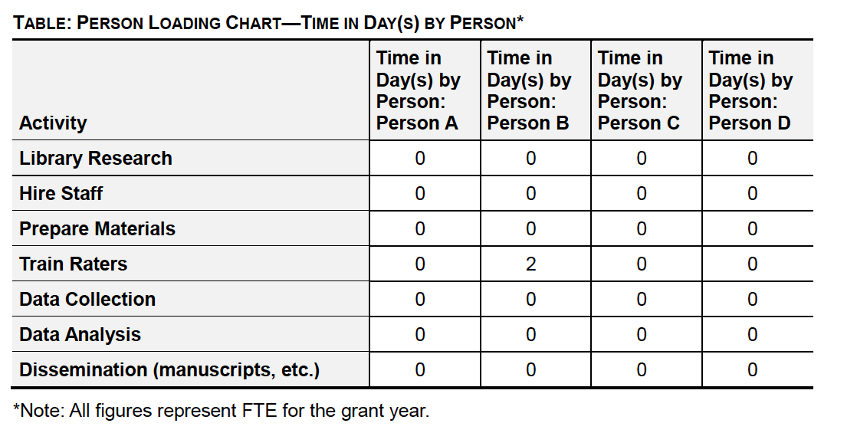
APPLICATION SUBMISSION INFORMATION
Refer to Section D of the Application Instructions pdf
Applicants are required to follow the Common Instructions for Applicants to Department of Education Discretionary Grant Programs, published in the Federal Register.
Link for “How to Apply for Grants:”
https://www.grants.gov/web/grants/applicants/apply-for-grants.html
When submitting, remember the recommended page limit (see specifics above). No more than 50 pages for the application narrative!
The recommended page limit does not apply to
  - Part I, the cover sheet;
  - Part II, the budget section, including the narrative budget justification;
  - Part IV, the assurances and certifications; or the abstract (follow the guidance provided in the application package for completing the abstract),
  - the table of contents, the list of priority requirements, the resumes, the reference list, the letters of support, or the appendices.

In addition, in order to submit your application via : https://www.grants.gov/web/grants, you must: (1) register as an applicant using your DUNS number and (2) be designated by your organization as an Authorized Organization Representative (AOR).

This is a product of the Early Childhood Personnel Center (ECPC) awarded to the University of Connecticut Center for Excellence in Developmental Disabilities and was made possible by Cooperative Agreement #H325B170008 which is funded by the U.S. Department of Education, Office of Special Education Programs. However, those contents do not necessarily represent the policy of the Department of Education, and you should not assume endorsement by the Federal Government.​

