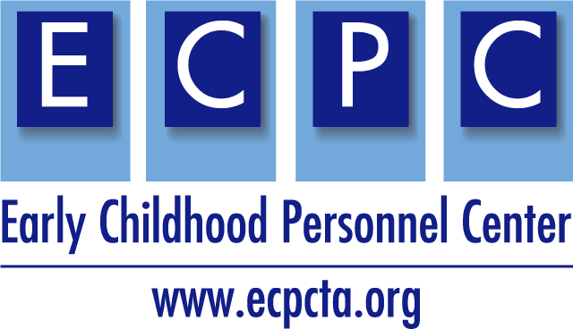
Name:
ECPC Materials Checklist for Higher Education Faculty
Select all you use
ECPC Curriculum Planning Tool
ECPC Adult Learning Planning Tool
ECPC Adult Learning Planning Tool with Examples
ECPC Program of Study Self-Assessment Checklist
ECPC Syllabi Checklist
Cross-Disciplinary Competencies
Cross-Disciplinary User Guide
Case Study Maria - Professionalism
Case Study Aiden - Coordination Collaboration
Case Study Antonia - Family-Centered Practice
Case Study Robert - Evidence-Based Intervention
Crosswalk of the EI/ECSE Standards (2020) with DEC RPs (2014)
Crosswalk of the EI/ECSE (2020) and ECE Standards (2020)
EI/ECSE Standards Curriculum Modules – Please share Module/tools used – select all that apply
Topics
Learning Activities
Sample Syllabi
Practicum Application (*new)
PD Guides
Multimedia Illustrations
Resources
E-Learning Lessons and Videos
Video Library (*new)

