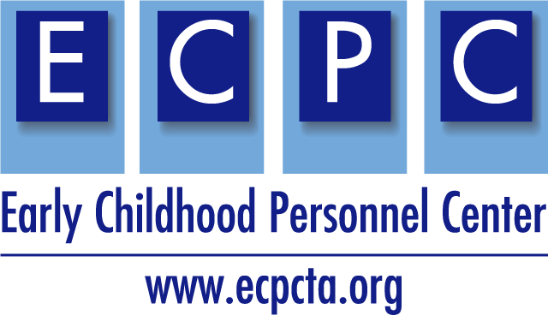
ECPC Checklist for Application Review

The ECPC Checklist for Application Review was developed for the U.S. Department of Education Office of Special Education and Rehabilitative Services, Office of Special Education Programs application for new grants under the Individuals with Disabilities Education Act (IDEA). The guidance contains information and resources for you to use when submitting a new application for funding under the Personnel Development to Improve Services and Results for Children with Disabilities: Personnel Preparation of Early Intervention and Special Education Personnel Serving Children with Disabilities who have High-Intensity Needs (ALN 84.325K) program. This guidance does not replace the OSERS-OSEP application packet, found in its entirety on grants.gov.
Once you have written your project narrative, use this checklist and consider the elements that the Secretary will review and score within your completed application.

Area of Application Review: Significance
10 Points
- The extent to which the proposed project will prepare personnel for fields in which shortages have been demonstrated; and  - The importance or magnitude of the results or outcomes likely to be attained by the proposed project, especially improvements in teaching and student achievement. | How does your proposal address this?

What do you need to add, delete, or modify to strengthen this section?

Area of Application Review: Quality of Project Services
35 Points
The quality and sufficiency of strategies for ensuring equal access and treatment for eligible project participants who are members of groups that have traditionally been underrepresented based on race, color, national origin, gender, age, or disability.  In addition:  - The extent to which the services to be provided by the proposed project reflect up-to-date knowledge from research and effective practice;  - The extent to which the training or professional development services to be provided by the proposed project are of sufficient quality, intensity, and duration to lead to improvements in practice among the recipients of those services;  - The extent to which the services to be provided by the proposed project involve the collaboration of appropriate partners for maximizing the effectiveness of project services; and  - The extent to which the proposed activities constitute a coherent, sustained program of training in the field. | How does your proposal address this?

What do you need to add, delete, or modify to strengthen this section?

Area of Application Review: (c) Quality of Project Personnel and Quality of Management Plan
20 points
1. The quality of the project personnel and the quality of the management plan.  2. The extent to which the applicant encourages applications for employment from persons who are members of groups that have traditionally been underrepresented based on race, color, national origin, gender, age, or disability.  3. Consider the following factors:  - The qualifications, including relevant training and experience, of key project personnel;  - The adequacy of the management plan to achieve the objectives of the proposed project on time and within budget, including clearly defined responsibilities, timelines, and milestones for accomplishing project tasks; and  - The time commitments of the project director and principal investigator and other key project personnel are appropriate and adequate to meet the objectives of the proposed project. | How does your proposal address this?

What do you need to add, delete, or modify to strengthen this section?

Area of Application Review: (d) Adequacy of Resources
20 points
Consider the following factors:  - The adequacy of support, including facilities, equipment, supplies, and other resources, from the applicant organization or the lead applicant organization; and  - The extent to which the costs are reasonable in relation to the objectives, design, and potential significance of the proposed project. | How does your proposal address this?

What do you need to add, delete, or modify to strengthen this section?

Area of Application Review: (e) Quality of Project Evaluation
15 points
- The extent to which the methods of evaluation are thorough, feasible, and appropriate to the goals, objectives, and outcomes of the proposed project;  - The extent to which the methods of evaluation will provide performance feedback and permit periodic assessment of progress toward achieving intended outcomes. | How does your proposal address this?

What do you need to add, delete, or modify to strengthen this section?

This is a product of the Early Childhood Personnel Center (ECPC) awarded to the University of Connecticut Center for Excellence in Developmental Disabilities and was made possible by Cooperative Agreement #H325B170008 which is funded by the U.S. Department of Education, Office of Special Education Programs. However, those contents do not necessarily represent the policy of the Department of Education, and you should not assume endorsement by the Federal Government.​

